INTRODUCTION
- State your question of interest
I would like to research on performance of major league baseball players. The exact question will be “predicting future offensive performance of major league baseball players”. I have been interested in this question due to the rise of advanced statistical-based analysis to predict how players will perform. The results from this research are of immerse use by baseball clubs which are geared towards signing players who will bring good results.
- State your hypotheses
The independent variables are age of the player, speed, ratio of ground balls to fly balls, Number of batted balls classified as a ground ball divided by total number of batted balls, number of balls classified as hard and percentage of pitches outside the strike zone that a batter swings at. The dependent variable is weight on-base average (WOBA). All the variables to be used are measured on a continuous scale.
From the above analysis we expect that there is positive relationship between WoBA and variables such as speed and ratio of ground to fly balls. This implies that as speed of a player increases, we expect his or her performance to be high. However, we do not expect linear relationship between age and player performance. Very young and inexperienced players are expected to perform badly and at their mid-ages their performance increases. At their advanced ages we expect their performance to reduce again.
METHOD
- Participants
My data targets major league baseball players each with minimum of 400 plate appearances. The sample respondents should be at least 18 years old so that I can get informed feedback. To ensure that the results are reliable, a sample size of 176 players is convenient. The analysis will secondary data which was collected from a survey conducted in USA. The essence of using secondary data is that it is easily accessible and not very costly to acquire.
- Materials
Materials used to collect the data is computer and statistical software to analyze the data. The secondary data used had a sample size of 176 baseball player who were above 18 years.

- Procedure
The analysis will start by conducting a descriptive statistic on all variable to a certain the distribution of the variables. To come up with a prediction model, regression analysis will be done where by the dependent variable is Weight on-base average and other variables are independent. To view individual relationship between the variables, scatter plots will be carried out for each dependent variable against independent variable. More statistical tests such as Dickey Fuller test and test for stationarity will also be done.
RESULTS
Statistical analysis to be carried out are descriptive statistics and regression analysis. We predict that most variables will have linear relationship between dependent and independent variable. The regression results are: -
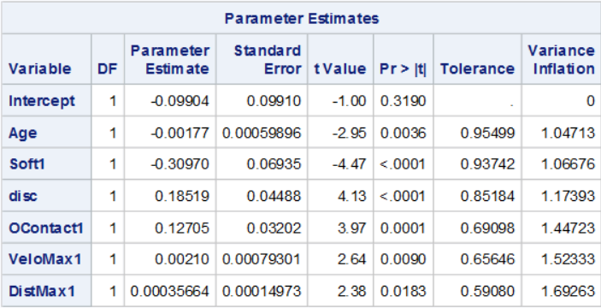
The stepwise selection method suggested a model with 7 variables. These variables were Age, OContact1, disc, DistMax1, Soft1, VeloMax1, and Speed. However, I eventually decided to exclude Speed from the model, since it was just barely significant at the chosen level, and it contributed minimally to the R-Square value of the total model. My concern was that Speed may no longer be significant if this analysis were repeated with a different dataset and is possibly only in this model as an effect of overfitting.
DISCUSSION
The goal of this project was to create a model that would adequately be able to predict batter performance in the upcoming year by using the previous year’s data. This goal was accomplished to a reasonable, with a R-Square value of .2939 and a standard deviation of 0.02956. Considering the league-average wOBA (approximately .320 each year), a player projected as average by this model would have a 68% (from the normal distribution) of finishing next year with a wOBA between .290 and .350..

